

Rosanna Cubs – Swimming night
WaterMarc Greensborough
Tuesday 19th March, 6:30pm-8pm

This week, we’ll be going swimming (and sliding) WaterMarc in Greensborough. This will be a fun night rather than a badge night – we’ll have a swimming night later in the year where we’ll do Swimming Badges.

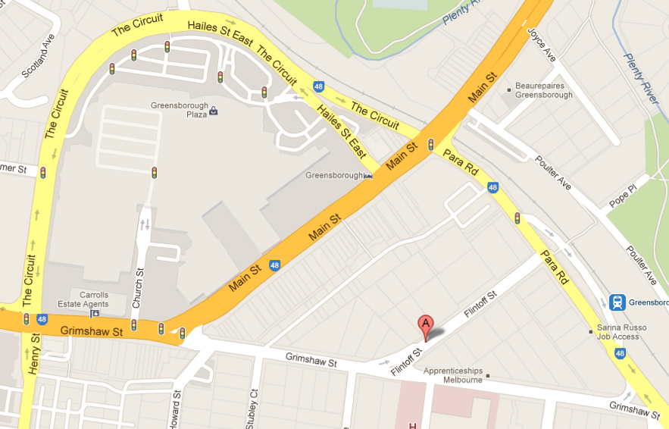
- Time: 6:30-8pm – Note different time to
normal Cubs
- Cost: $9 per Cub. Others will be at
normal prices – refer
www.watermarcbanyule.com.au
- Location: WaterMarc Aquatic Centre –
1 Flintoff St, Greensborough
- Bring: Togs, Towel, warm clothes to go
home in

Don’t miss out – see you there (if you have trouble getting there, please talk to Akela (0411 121 495) and we’ll see what we can arrange)!

Regards

The Leaders
Rosanna Cub Scouts

See us at http://www.rosannacubs.org

